

2024 Remittance Report Instructions
The Connecticut Bar Foundation is providing the following instructions for submitting financial institution IOLTA remittance reports. Please direct any questions to:
Gina J. Casella
IOLTA Administrative Assistant
860-937-5487
gina@ctbarfdn.org

Ashleigh M. Backman
Deputy Director/
Chief Operating Officer
860- 206-5727
ashleigh@ctbarfdn.org

Remittance Reports
A single electronic remittance report for all accounts at the bank must be submitted for each remittance period (monthly), whether or not interest has been earned on those accounts. Banks should use IOLTA’s pre-formatted Excel template. The template (which includes a sample report) was provided with these instructions [. Please contact the Foundation with any questions on file format or problems with your upload.

The remittance report file name should include the bank name and indicate the period covered by the report (bank_name_remittanceperiod.xlsx). Examples:
FirstNationalBank_jan2024.xlxs

Submitting a Remittance Report
- Register to Use the Remittance Upload System (RUS)
To utilize the IOLTA remittance upload system (RUS), participating bank users first must register.
Note: Each participating bank may have a maximum of three users. Each user must utilize a separate email address. To delete a user or reset a password, submit a request by email to the Foundation at gina@ctbarfdn.org.

To access the remittance upload system (RUS), please visit:

https://ctbfrus.org/

- Under “Register for Access,” Click Register, which will bring up the following:
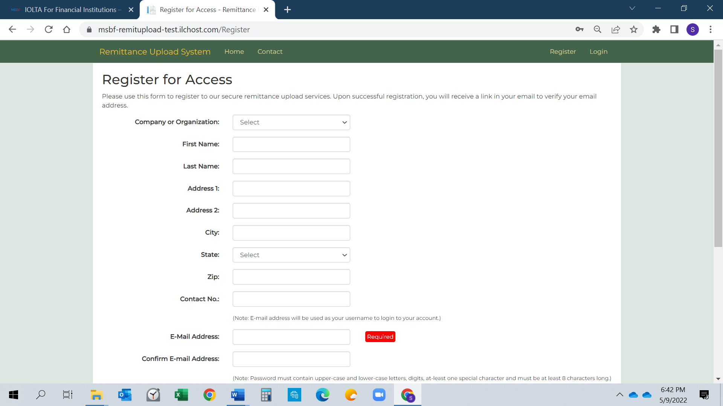

  - Select your banking institution from the drop down menu and complete the form, including creating a new password. (Your email address and password will be used to access RUS for all future submissions.) Click the “I’m not a robot” checkbox and click Submit.

  - If successful, the following message will appear:

Thank you for your registration! You will receive an email containing a link to verify the email address you provided. Please verify your email address to activate your account.
  - Within a few minutes, you will receive an email from no-reply@ctbfrus.org. Open the email and click (as shown below) to complete the registration process. If you do not receive the confirmation email please check your junk or spam email folders.
- To ensure delivery of the registration email, please record the domain ctbfrus.org as a safe sender in your email system. (This may require contacting your IT department for assistance).
- Clicking the link click here in the email (example below) will open a new browser window with a message confirming that your email address has been verified and that the registration process is complete.
===================================================================================================================================
Dear XXXX,
You have registered for the Connecticut Bar Foundation IOLTA Remittance Upload System as a bank representative. Please review the following information for accuracy:
Company or Organization: XYZ Bank, NA
First Name: Joe
Last Name: Smith
Address1: 123 Main St
Address2:
City: Hartfordt
State: Ct
Zip: 12345
Phone: 1 788-233-9090
E-Mail Address: joe.smith@xyzbank.com
If this information is correct, please click here to verify your email address and activate your account. This link will expire in 24 hours.
If this information is not correct, please contact the Conneticut Bar Foundation at 860-937-5487
Thank you!
Note: This is an automated email from the Connecticut Bar Foundation Remittance Upload System. Please do not reply to this email.
===========================================================================================================================
  - Important: This is an automated email. Please do not reply. Direct any questions to gina@ctbarfdn.org or ashleigh@ctbarfdn.org.

  - The automated email must be replied to within 24 hours. In the event the registrant fails to confirm the email on time or if your security system blocks the email, please call us to request a verification through alternate means.

Uploading Remittance Files
After registering, visit RUS to upload a Remittance File, an Adjustment File, or a Closed Account File.

Return to https://ctbfrus.org/

This will again bring up the RUS main page:

  - Under “Login,” click Login.

  - Enter your username (email address) and the password you created during the registration process and click on the “I’m not a robot” checkbox.
(This is your permanent username and password for the RUS system)

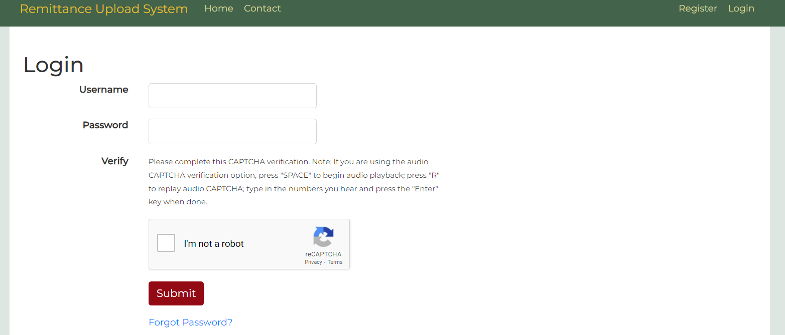

  - You are now logged into RUS.

  - Choose the type of file to be submitted from the drop-down menu (Remittance File, Adjustment File or Closed Accounts File).

Remittance File – This file type contains remittance data for regular monthly reporting periods.
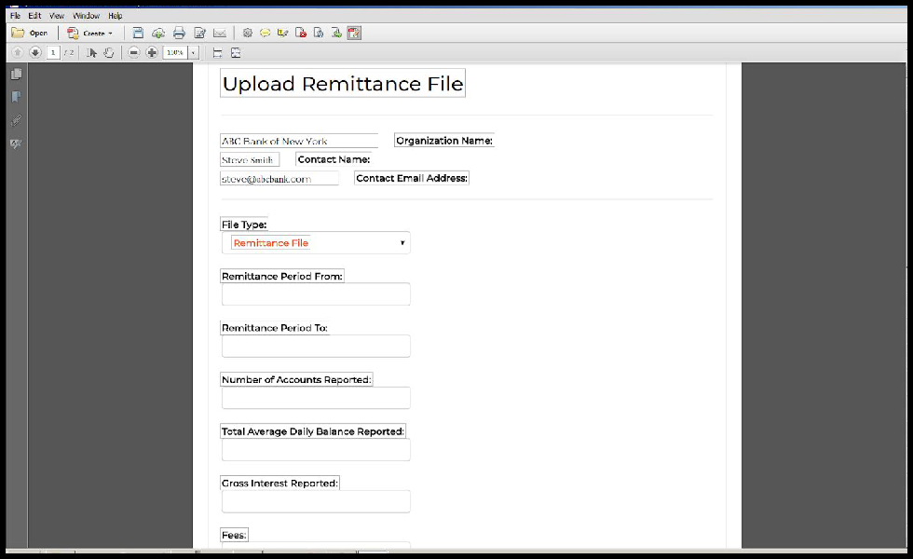

    - Complete all fields on the form (fields with (*) will be validated):
      - Beginning and end dates of the period being reported.
      - *Total number of accounts.
      - *Total average daily balances of the accounts for the period.
      - *Gross interest.
      - *Fees (if applicable).
      - *Net interest.
    - If all IOLTA accounts are paid the same rate, choose the Single Interest Rate button and enter the flat rate.

    - If tiered rates are paid, choose the Tiered Interest Rate button and enter each level of balance and rates.
Adjustment File - This file format is identical to the remittance file type but contains remittance data missing or corrected from time periods that have already been reported. Institutions may use the same remittance template as regular remittances.
    - The upload process for an Adjustment File includes the same required fields as a Remittance File and contains the same selection of Single Interest Rate or Tiered Interest Rate.
    - There is an additional text field labeled Reason for the Adjustment. Here, write a brief explanation for the adjustment.

Closed Accounts File – This file type contains data of accounts that have been closed during the reporting period.
    - The template for the Closed Accounts File form requires the following content:
      - Column A is the account name,
      - Column B is the account number and,
      - Column C is the closed date (mm/dd/yyyy)
    - Select the file you wish to be uploaded from your local directory by clicking the Choose File button and double clicking the file from the appropriate directory once identified.

  - After completing the required fields for the file type (Remittance File, Adjustment File, or Closed Accounts File), click Verify.

Validation
To streamline the remittance process, the remittance file you submit will be automatically validated by RUS to ensure its accuracy and integrity.

Certain fields, those denoted above with (*), will be validated against the contents of the file that was uploaded. The uploaded file will also be evaluated to ensure that fields calculate correctly, that there are no extraneous data in the file, and that the fields are properly formatted (e.g., numbers in number fields).

If a discrepancy is found, RUS will report to you the error and the line of the report that contains the error. You will then have an opportunity to correct the error and resubmit the file.

Once the file is successfully validated, you will receive this message:

File validated, Thank you. Please verify the information entered above and click 'CONFIRM SUBMISSION' to confirm and complete processing for this remittance.

Click Confirm Submission and you will receive this message:

File submitted successfully. You may log out or upload another file.

Repeat this process each time you submit a remittance file.

